**Install grSim on windows**

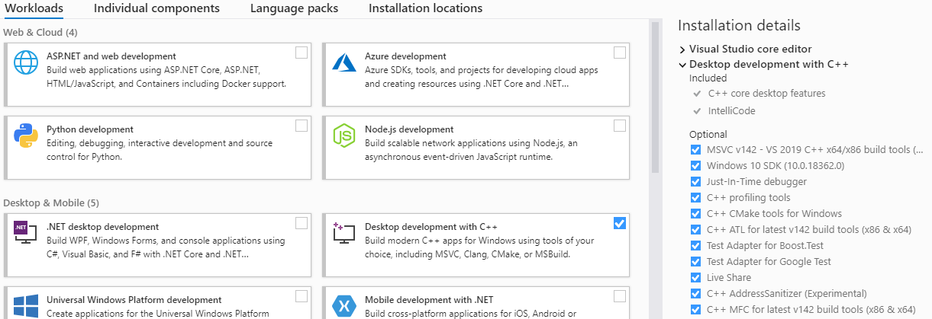-Install visual studio with Desktop Development with c++. Also mark C++ MFC for latest build (see image below).



-Install cmake (tested with version 3.17.2 on win64), add it to the path.

<https://cmake.org/download/>

-Install vcpkg by cloning the project into C:\ or D:\



<https://github.com/Microsoft/vcpkg>

Read quick start section

As per the instructions run “.\bootstrap-vcpkg.bat” and “.\vcpkg integrate install”

-Open a console window in vcpkg installation folder.

-Install packages qt5, ode and protobuf by running the following command (this will take a long long time):

$ .\vcpkg install qt5:x64-windows ode:x64-windows protobuf:x64-windows

Clone grsim and open the folder.

In file “CMakeLists.txt”:

Replace lines 72 , 73 and 84 from (note in line 84 you must use your own path):

72: find_package(ODE REQUIRED)

73: list(APPEND libs ode::ode)

84: CMAKE_ARGS "-DVARTYPES_BUILD_STATIC=ON;-DCMAKE_INSTALL_PREFIX=<INSTALL_DIR>"

TO:

72: find_package(ode CONFIG REQUIRED)

73: list(APPEND libs ODE::ODE)

84: CMAKE_ARGS "-DCMAKE_TOOLCHAIN_FILE=D:/vcpkg/scripts/buildsystems/vcpkg.cmake;-DVARTYPES_BUILD_STATIC=ON;-DCMAKE_INSTALL_PREFIX=<INSTALL_DIR>"

In file: “src\configwidget.cpp” replace:

Line 22:

From:

v_##name = std::shared_ptr<Var##type>(new Var##type(namestring,Defaultvalue));

TO:

v_##name = std::shared_ptr<VarTypes::Var##type>(new VarTypes::Var##type(namestring,Defaultvalue));

Line 24:

From:

v_##name = std::shared_ptr<Var##type>(new Var##type(namestring,defaultvalue)); \

TO

v_##name = std::shared_ptr<VarTypes::Var##type>(new VarTypes::Var##type(namestring,defaultvalue)); \

Open a console, navigate to grsim’s folder and execute the following commands (NOTE: you must use your own path in the last command)

$ mkdir build

$ cd build

$ cmake .. -DCMAKE_TOOLCHAIN_FILE=D:/vcpkg/scripts/buildsystems/vcpkg.cmake

If everything worked fine, you should have a file “grSim.sln”, open it with visual studio.

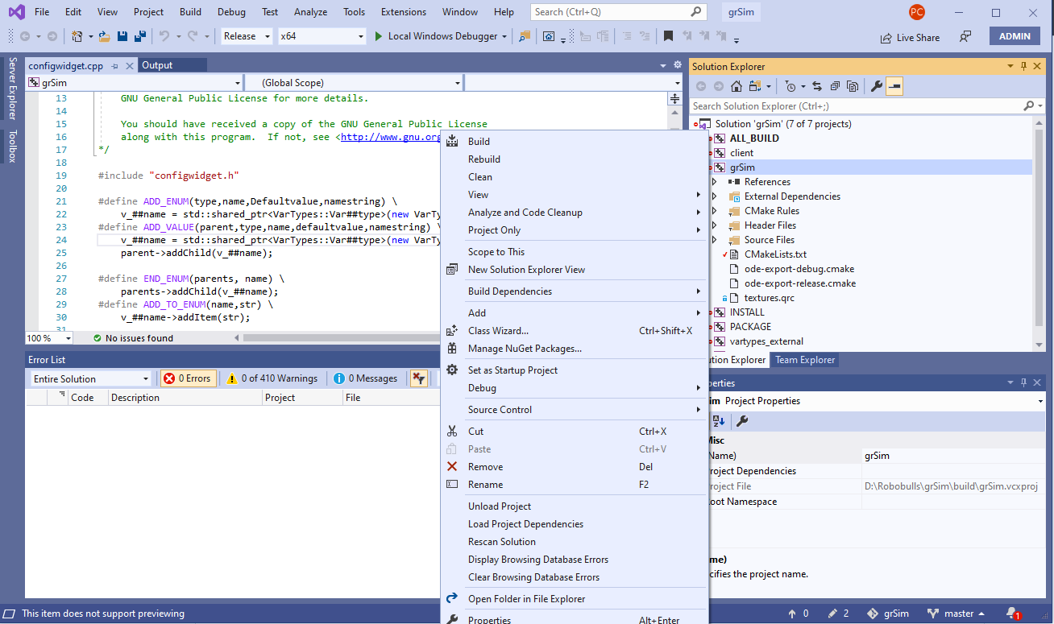Change the configuration from “debug“ to “release”, then build project “grsim” (secondary click in the project and then build).



**1**

**2**

**3**

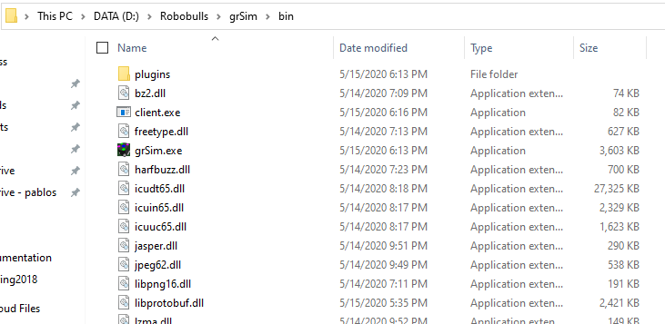Finally, grsim will be located in bin along with all required dlls and a client to test it.

